**GREENLEAF SALES ANALYSIS REPORT**

**- BY SAKSHI SAHU**

**DATA ANALYST**

**CONTENTS**

**1. EXECUTIVE SUMMARY 1**

**2. DATA SUMMARY 1**

2.1. Time Period 1

2.2. No. of Records: 1

2.3. No. of Columns: 1

2.4. Key Features: 1

2.4.1. Product Table 1

2.4.2. Sales Table 1

**3. METHODOLOGY OF ANALYSIS 1**

3.1. Extract 1

3.2. Transform 2

3.3. Load 2

**4. VISUALIZATIONS & INSIGHTS 2**

**5. KEY FINDINGS 9**

**6. CONCLUSION & RECOMMANDATION 10**

1. **EXECUTIVE SUMMARY**
   1. **Purpose of the analysis:** Gain a deeper understanding of GreenLeaf’s sales performance across products, channels, and teams. By studying historical transaction data, the analysis aims to uncover patterns, highlight growth opportunities, and address inefficiencies in the current sales process.
   2. **Objective of the analysis:** Translate raw sales data into actionable insights that support strategic decisions - such as identifying high and low-performing products, evaluating the effectiveness of sales channels, and measuring salesforce productivity. Ultimately, the analysis will guide GreenLeaf in optimizing its portfolio, strengthening channel strategies, and driving overall business growth.
2. **DATA SUMMARY**
   1. **Time Period:** Jan 2019 - March 2021
   2. **No. of Records:**

* **798** records in Product Table
* **260K+** records in Sales Table
  1. **No. of Columns:**
* **4** columnsin Product Table
* **10** columns in Sales Table
  1. **Key Features:**
     1. **Product Table**
* Product ID
* Product Name
* Product Group
* Product Category
  + 1. **Sales Table**
* **Order Date**
* Order Number
* Product ID
* Salesperson ID
* Salesperson
* Supervisor
* Manager
* Channel
* Quantity
* Unit Price

1. **METHODOLOGY OF ANALYSIS**
   1. **Extract**

* **Data source:** Extracted the raw data which is in multiple tables from Excel to Power BI.
* **Data understanding:** The dataset contained **two main tables - Products and Sales.**
* The p**roduct table** contains 1 identifier and 3 categorical fields. While, sales **table** contains 1 date field, 3 identifiers, 4 categorical fields, 1 count field and 1 continous field.
* **Schema understanding:** **Product table** serves as the **dimension/parent** table and s**ales table** serves as the **fact/child** table (transaction-level data) for the analysis.
* Initially, the relationship between the Product and Sales tables was broken due to mismatched column names. This was resolved by renaming the 'Product ID' field in the Sales table to ensure it matched the corresponding field in the Product table.
* **Data exploration:** No missing values, wrong values and duplicated records found in any column of either table.
* Quantity and Unit Price field values were checked and no outlier were found, all values are within reasonable business ranges.
* All columns had correct data types except **Order Date**, which was converted to Date type for proper time-based analysis.
  1. **Transform**
* **Data cleaning:** Corrected the data type of the 'Order Date' column to Date.
* Outliers in the price column were retained, as product prices can vary widely.
* **Data transformation:** Merged both tables into a consolidated table named **Final Sales**.
* Created a new calculated column:

**Sales = Unit Price × Quantity**

* Dropped unimportant fields that did not add analytical value, such as **Product ID** and **Salesperson ID**, after merging.
  1. **Load**
* Finally the dataset is now **clean, structured, and analysis-ready**, containing enriched fields like **Sales Amount**, along with relevant product, channel, and managerial hierarchies.

1. **VISUALIZATIONS & INSIGHTS**
   1. **Product group wise sales.**

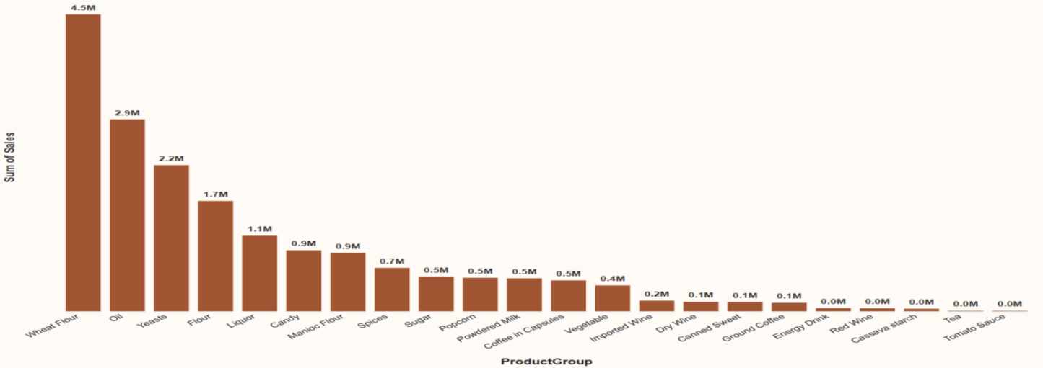

* **Observation:** Wheat Flour leads at sales, followed by Oil and Yeasts as the main revenue drivers. Mid-tier products like Flour, Liquor, Candy, Manioc Flour, and Spices contribute moderately, while categories such as Vegetables, Wines, Coffee, Tea, and Tomato Sauce record very low sales. *Overall,* *sales are dominated by a few core products, with most other categories underperforming*.
  1. **Top 5 product group.**

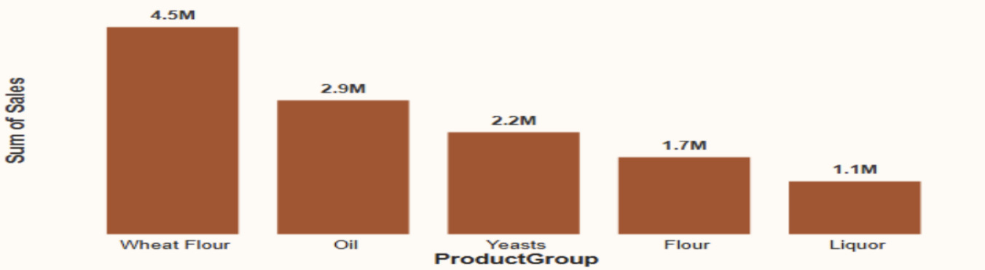

* **Observation:** The top-performing product group is **Wheat Flour** with sales of **4.5M**, significantly ahead of other groups. **Oil** (2.9M) and **Yeasts** (2.2M) also contribute strongly, while **Flour** (1.7M) and **Liquor** (1.1M) show relatively lower sales. *This indicates that staple food items like wheat flour and oil are the main revenue drivers.*
  1. **Bottom 5 product group.**

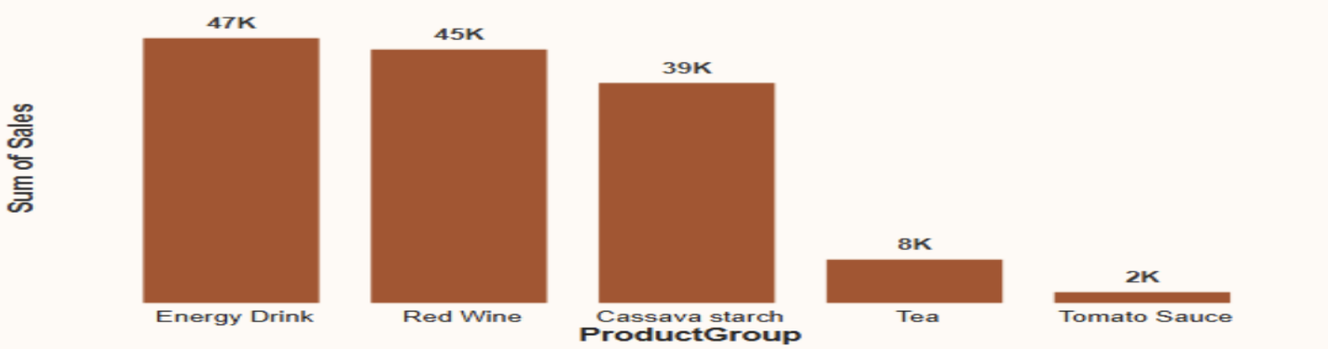

* **Observation:** Energy Drink, Red Wine, Cassava Starch, Tea, and Tomato Sauce - have the lowest sales performance, with Tomato Sauce contributing the least at just 2K. These categories show weak demand compared to others and add minimal value to overall revenue.
  1. **Product category wise sales.**

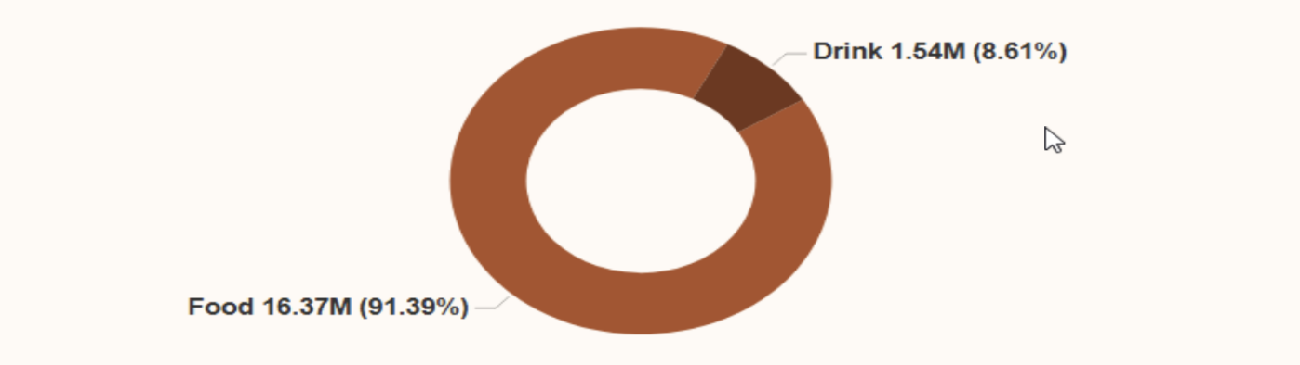

* **Observation:** Sales are heavily dominated by the Food category, which contributes **91.39% (16.37M)** of total sales, while the Drink category accounts for only **8.61% (1.54M)**. This indicates that the business is highly reliant on food products, with beverages playing a comparatively small role in revenue generation.
  1. **Sales trend over the years.**

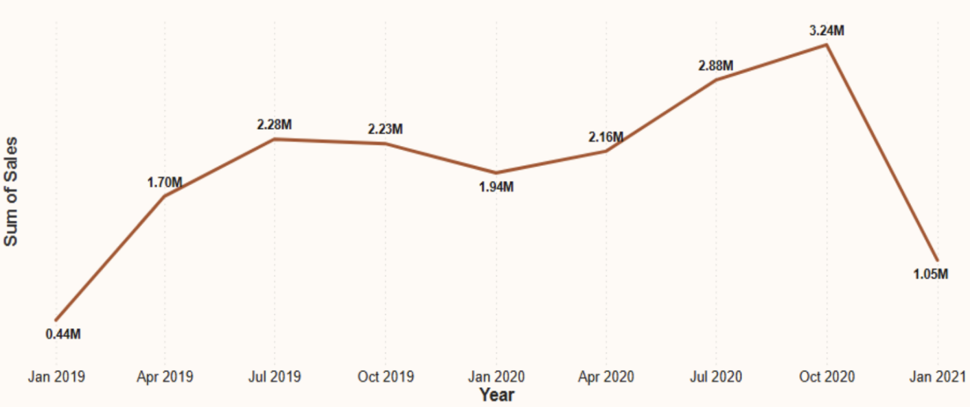

* **Observation:** Sales showed strong growth from **2019 to 2020**, with revenue rising from **0.4M in Jan 2019** to a peak of **3.2M in Oct 2020**. However, sales declined sharply to **1.05M in Jan 2021**, indicating possible seasonal fluctuations or external market factors impacting performance at the start of 2021.
  1. **Product group sales by channel.**

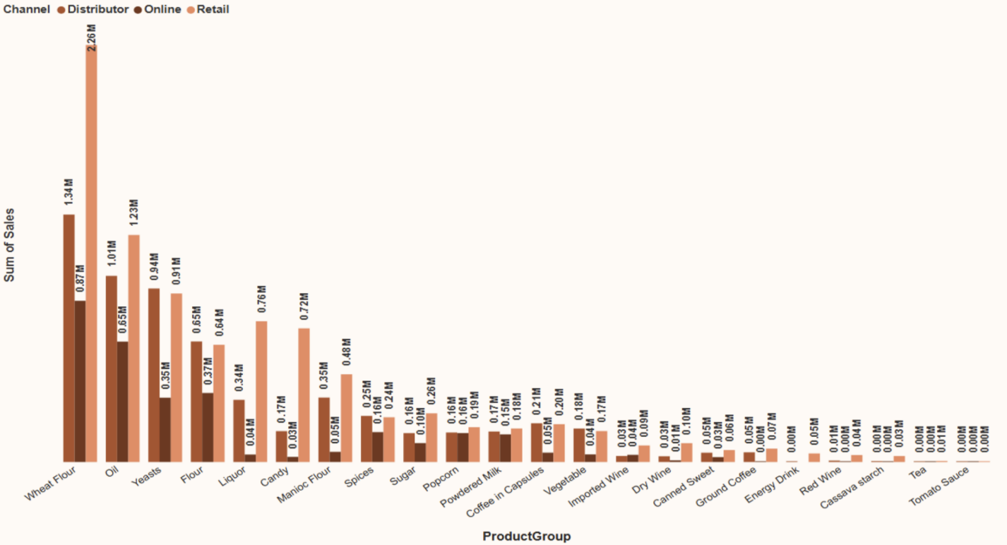

* **Observation:** Across all product groups, **Wheat Flour dominates sales**, particularly in the **Retail and Distributor channels**, while Online contributes relatively less. Similar patterns are seen for Oil, Yeasts, and Flour, highlighting that Retail and Distributor are the primary revenue drivers. This suggests a strong dependency on traditional sales channels, with Online remaining an underutilized growth opportunity.
  1. **Product category sales by channel.**

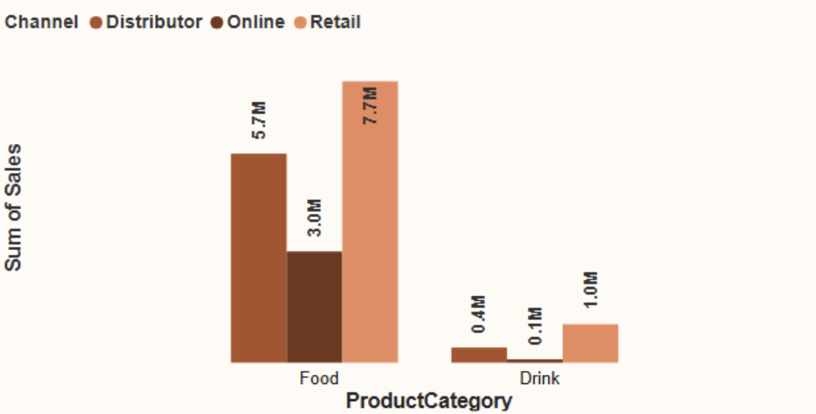

* **Observation:** Food products dominate across all sales channels, with **Retail (7.7M)** contributing the highest share, followed by **Distributor (5.7M)** and **Online (3.0M)**. Drink products, however, show minimal sales, with only **1.0M in Retail** and negligible performance in Distributor and Online channels. *This indicates that the business is heavily reliant on Food sales, particularly through Retail.*
  1. **Overall channel-wise sales contribution.**

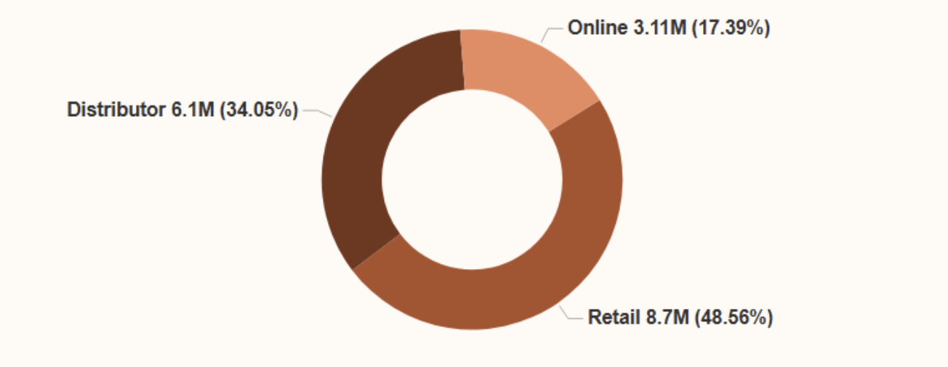

* **Observation:** Retail is the leading sales channel, accounting for **48.56% (8.7M)** of total sales, followed by Distributor at **34.05% (6.1M)**, while Online contributes the smallest share at **17.39% (3.1M)**. This highlights the importance of strengthening Retail and Distributor operations, while also exploring strategies to boost Online sales for balanced growth.
  1. **Key influencers of sales.**

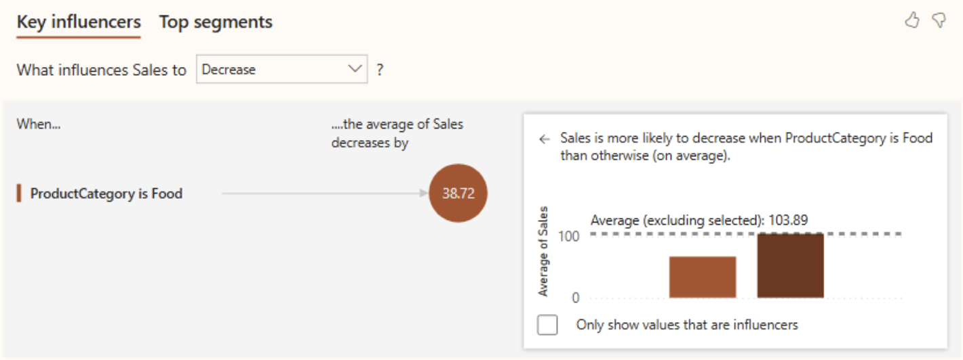

* **Observation:** Found a strong correlation between a decrease in sales and the ProductCategory being Food. As seen, when the product category is food, the average sales decrease by 38.72.
  1. **Salesperson sales performance.**

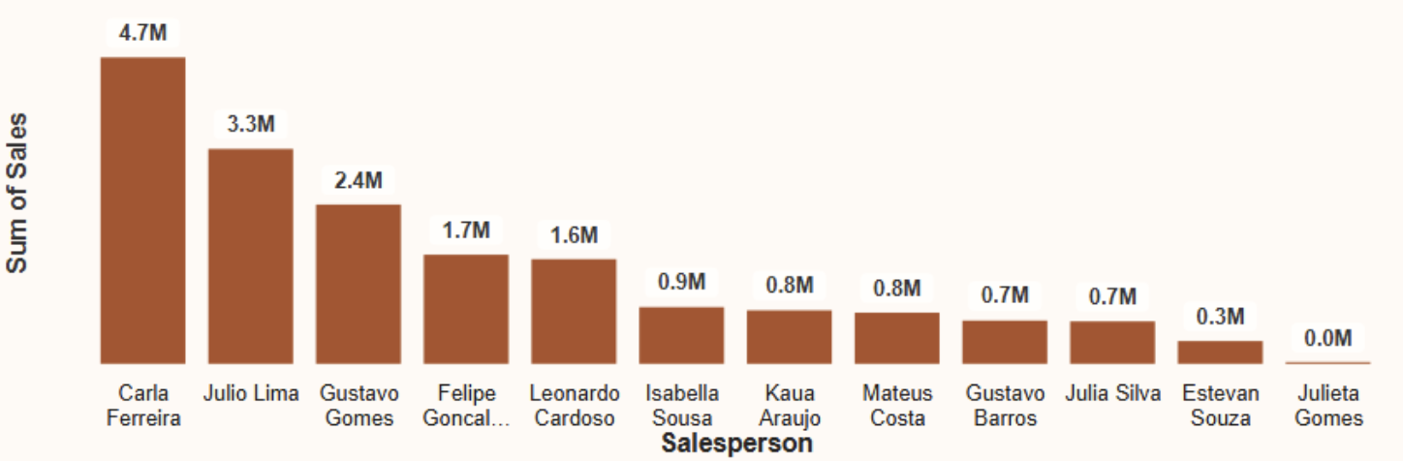

* **Observation:** A clear breakdown of individual sales performance across the team. Top performer is Carla Ferreira with total sales of $4.7 million, followed by Julio Lima with $3.3 million.
  1. **Top 5 salesperson by performance.**

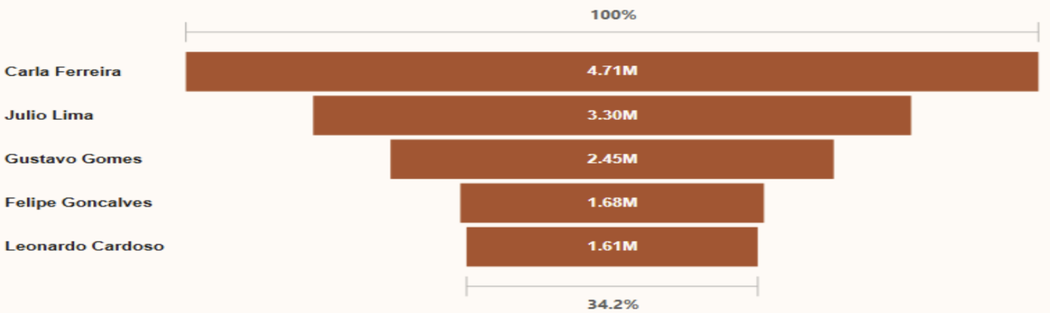

* **Observation:** The top two performers, Carla Ferreira and Julio Lima, account for a combined total of 8.09M in sales, capturing a large portion of the overall sales.
  1. **Supervisor sales performance.**

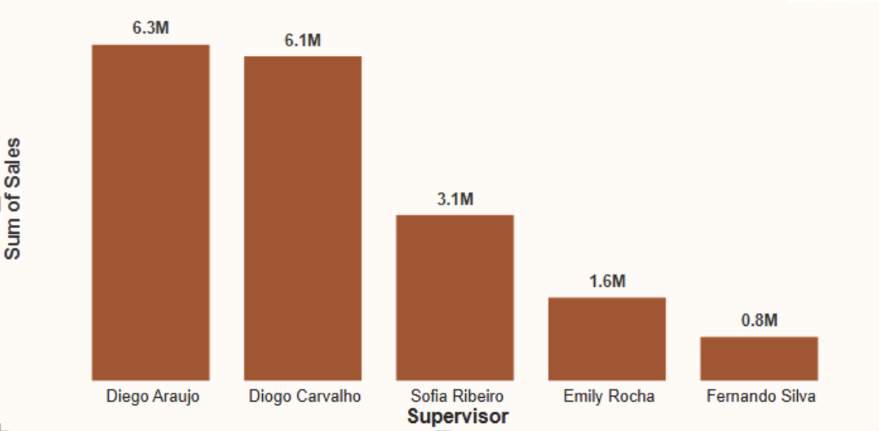

* **Observation:** Diego Araujo and Diogo Carvalho are the top performing supervisors, with significantly higher sales than the rest of others.
  1. **Manager sales performance.**

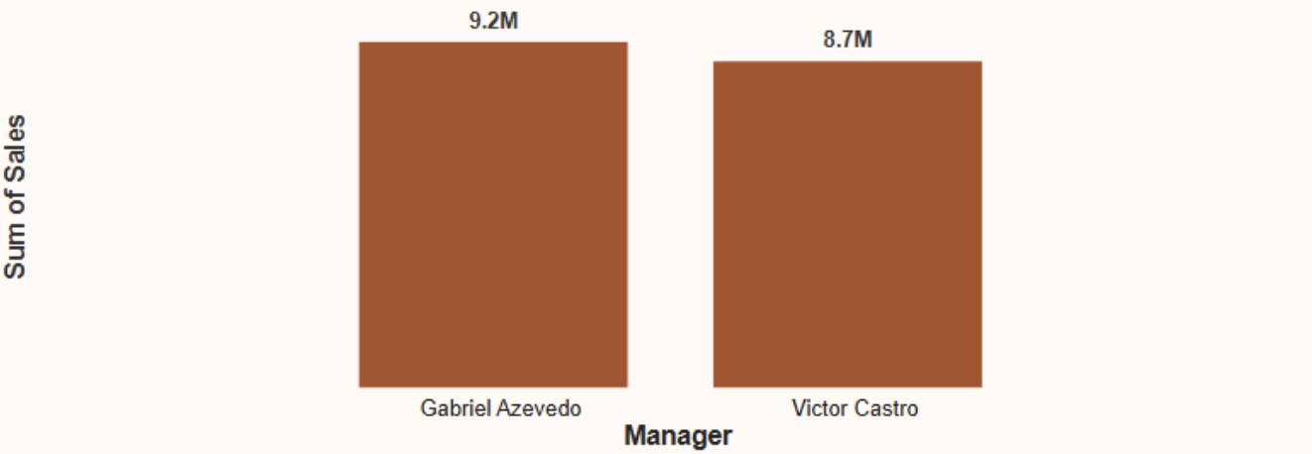

* **Observation:** Gabriel Azevedo leads with a total of $9.2M in sales, followed closely by Victor Castro at $8.7M. This minor difference of just $0.5M suggests a highly competitive yet balanced performance between the two.
  1. **Sales-team performance summary.**

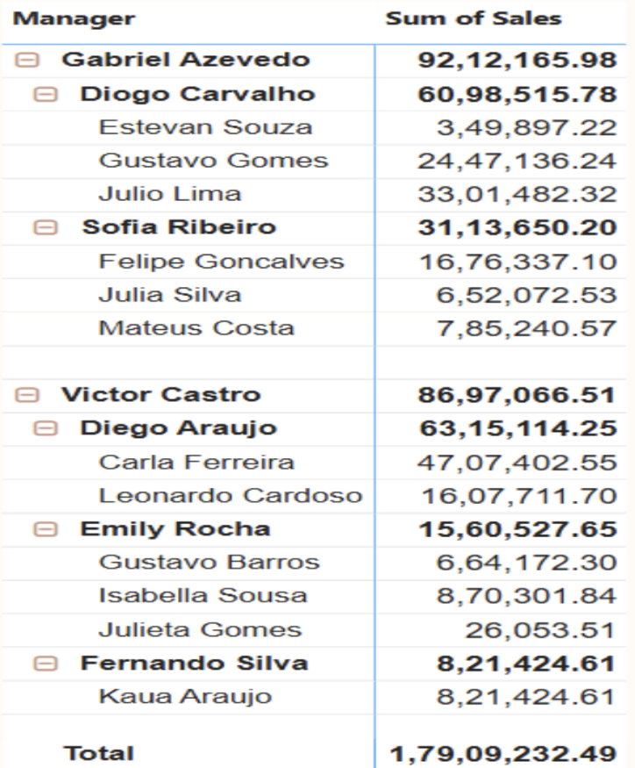

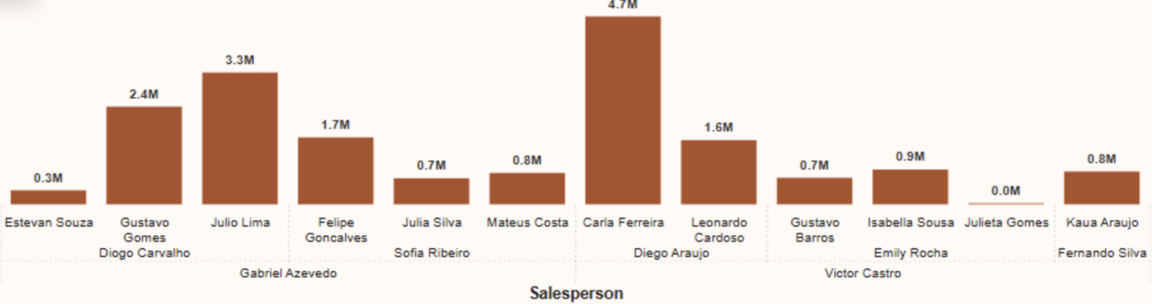

* **Observation:** Both managers lead high-performing teams, Gabriel's team is heavily driven by a single top performer, whereas Victor's team demonstrates more balanced contributions across its members.
  1. **Sales trend by product category.**

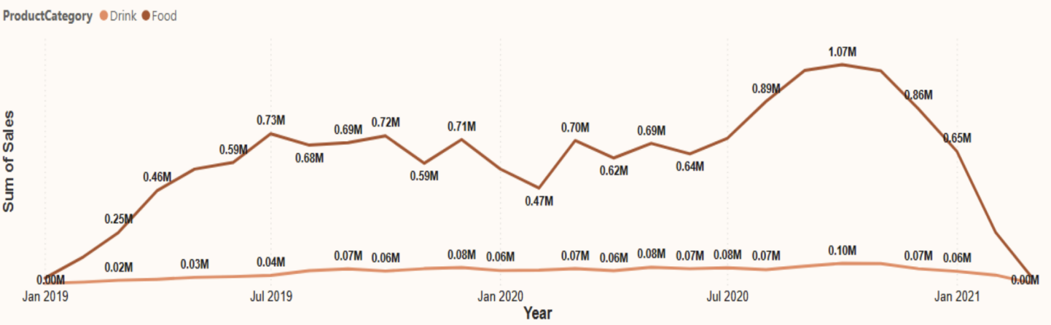

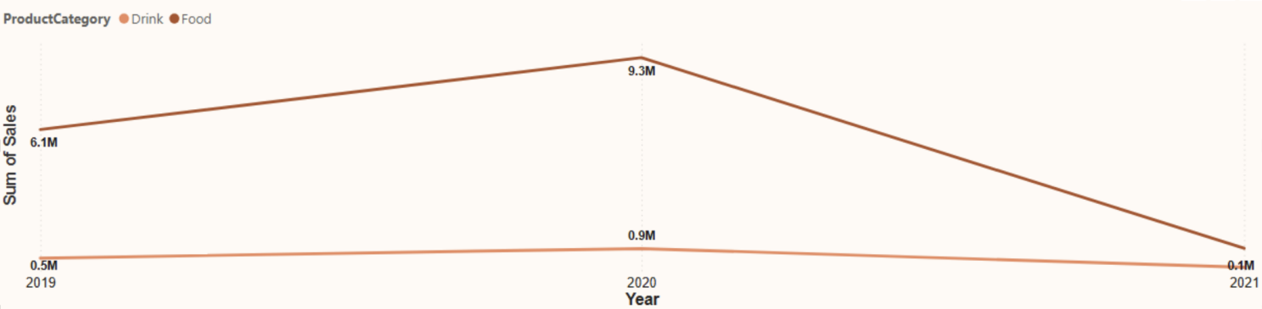

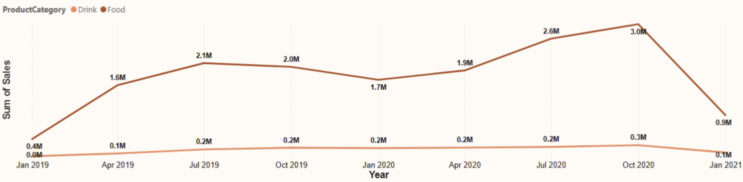

* **Observation:** It reveals a consistent trend where food sales significantly outperform drink sales. Drink sales, in contrast, remain relatively low and stable, never exceeding $0.10M.

1. **KEY FINDINGS**

The analysis highlights that **Food products dominate GreenLeaf’s sales**, contributing more than 91% of total revenue, while **Drinks remain underdeveloped** at only 9%. Within Food, items such as **Wheat Flour, Oil, and Yeasts** are the strongest drivers, whereas products like **Tomato Sauce and Tea** show weak performance.

Sales trends reveal strong growth through 2019 and 2020, peaking in **October 2020 (3.2M)**, followed by a noticeable decline in early 2021. From a channel perspective, **Retail leads with nearly half of total sales**, while **Online sales lag behind at 17%**, signaling a gap in digital reach.

1. **CONCLUSION & RECOMMANDATION**

Overall, GreenLeaf has established a strong base in Food products and retail distribution, but its reliance on these areas creates risk in the long term. The underperformance of Drinks and Online channels indicates untapped potential that the company should prioritize.

Additionally, bridging the performance gap across salesperson could drive more consistent results. By focusing on **category diversification, strengthening online presence, and sharing best practices from top performers**, GreenLeaf can achieve more balanced and sustainable growth in the future.